Synopsis
On
Online Car Pooling System
Submitted in partial fulfilment of the Requirements
For the award of Master of Computer Application Degree (MCA-4th ^{SEM})

HIMACHAL PRADESH TECHNICAL UNIVERSITY, HAMIRPUR



SCRIPTING LANGUAGE-LAB+MAJOR CASE STUDY

Submitted by: Submitted To:
Anuj Rana Mrs Susheela Pathania
Roll No: 21252
Uni. Roll No: 21013728009

DEPARTMENT OF MASTER OF COMPUTER APPLICATION



GOVT. P.G. COLLEGE
DHARAMSHALA
SESSION – 2021-23

INDEX
SR.NO | Contents | PAGE
 | Introduction of the Project
 | Problem Description
 | Objectives of the Project
 | Project Category
 | Project Selection Criteria
 | Hardware and Software Requirement
 | Project Planning and Scheduling
 | Module Description
 | Data Models - 0, 1 and 2 level DFDs
 | ER Diagrams
 | Conclusion
 | Bibliography

- INTRODUCTION OF THE PROJECT

- The carpooling system is an innovative transportation solution that aims to reduce traffic congestion, air pollution, and transportation costs by facilitating ride-sharing among commuters. The system provides a platform that connects drivers who are traveling to the same destination with passengers who are looking for a ride.

- Carpooling is becoming an increasingly popular alternative to driving alone, particularly in densely populated areas where traffic congestion is a major problem. The carpooling system seeks to make it even easier for individuals to find and share rides with others, reducing the number of cars on the road, improving air quality, and helping to reduce traffic congestion.

- The carpooling system will be designed to be easy to use and accessible through a web that allows users to create and manage their ride-sharing requests. The system will match drivers with passengers based on their location, destination, and travel schedule, making it a convenient and efficient way for people to commute.

- Moreover, carpooling provides a social and economic benefit. It allows for the creation of new connections and relationships and promotes shared experiences. Additionally, it is a cost-effective way of traveling, reducing transportation expenses such as gas, tolls, and parking fees.

- The purpose of the carpooling system project is to provide a sustainable and cost-effective transportation solution that can help alleviate traffic congestion, reduce air pollution, and promote social connections. The carpooling system aims to provide a convenient and accessible platform for drivers and passengers to find and share rides with each other.

- Traffic congestion is a significant issue in many urban areas, and it can cause many problems such as increased travel time, stress, and air pollution. By reducing the number of vehicles on the road through carpooling, the system can help reduce traffic congestion and improve overall traffic flow.

- Air pollution is another major problem that can cause negative health effects and environmental damage. The transportation sector is a significant contributor to air pollution, and carpooling can help reduce the emissions of greenhouse gases and other harmful pollutants.

- Carpooling also provides significant cost savings for commuters. By sharing the cost of transportation, car poolers can save money on fuel, tolls, parking fees, and other transportation expenses.

- In addition, carpooling can provide social benefits by promoting shared experiences and connections among individuals who share rides with each other.

- Overall, the carpooling system represents a promising solution to some of the most pressing transportation and environmental issues. By encouraging more people to share rides, the system can help create more sustainable and efficient transportation systems while benefiting both the environment and commuters alike.

- PROBLEM DESCRIPTION

- Traffic congestion:

- Traffic congestion is a common problem that affects many transportation systems, including carpooling systems. In a carpooling system, traffic congestion can lead to longer travel times and reduce the efficiency of the ride-sharing process.
- One way to address traffic congestion in a carpooling system is to encourage more people to participate in ride-sharing. By increasing the number of individuals who are willing to share rides, the system can reduce the number of cars on the road, leading to less traffic congestion and smoother traffic flow.
- Another way to address traffic congestion is to use technology to optimize the carpooling process. This can involve using algorithms and data analytics to match drivers and passengers more efficiently, taking into account factors such as traffic patterns, travel times, and preferred routes.
- Additionally, carpooling systems can incentivize off-peak travel, encouraging individuals to travel during non-peak hours to reduce traffic congestion during busy times. This can be done through promotions, discounts, and other incentives for car poolers who travel during off-peak times.

- Environmental impact:

- Carpooling systems can have a positive environmental impact by reducing the number of vehicles on the road and thus reducing emissions of greenhouse gases and other pollutants. The environmental benefits of carpooling are significant, as transportation is a major contributor to air pollution and climate change.
- By encouraging more people to share rides through a carpooling system, the number of vehicles on the road can be reduced, resulting in lower emissions of greenhouse gases such as carbon dioxide, methane, and nitrous oxide. Carpooling can also reduce emissions of harmful air pollutants such as nitrogen oxides, sulphur dioxide, and particulate matter, which can have negative health effects on humans and the environment.
- Moreover, carpooling can also help reduce the demand for fossil fuels, which are a finite resource and contribute to climate change. By sharing rides, car poolers can reduce their individual fuel consumption and save money on fuel costs. This can also reduce the need for oil drilling, refining, and transportation, which can have significant environmental impacts such as oil spills and habitat destruction.
- Finally, carpooling can promote sustainable transportation habits and encourage individuals to consider the environmental impact of their transportation choices. By providing a sustainable and convenient alternative to driving alone, carpooling systems can help promote a more environmentally conscious lifestyle.

- Fuel costs:

- Fuel costs are a significant factor in the overall cost of transportation, and carpooling systems can help reduce fuel costs for individuals who participate in ride-sharing. By sharing rides, car poolers can split the cost of fuel, leading to significant cost savings compared to driving alone.
- The cost savings of carpooling can be significant, particularly for individuals who have long commutes or who live in areas with high fuel prices. Carpooling systems can provide a platform for individuals to find compatible carpool partners, enabling them to share the cost of fuel and reduce their transportation costs.
- Moreover, carpooling systems can incentivize fuel-efficient driving behaviour, such as reducing speeds, avoiding sudden accelerations and braking, and properly maintaining vehicles. These behaviours can help reduce fuel consumption and further lower fuel costs for car poolers.

- Parking:

- Parking is an important consideration in carpooling systems, as finding a parking spot can be a significant challenge, especially in urban areas. However, carpooling systems can help reduce the demand for parking by encouraging shared rides and reducing the number of cars on the road.
- In many cases, car poolers can save money on parking costs by sharing a parking spot or by using a carpool-only parking space. These spaces are typically reserved for cars with multiple occupants, providing an incentive for carpooling and reducing the demand for parking spots.
- Moreover, carpooling systems can provide a platform for individuals to find carpool partners who live in the same neighbourhood or work in the same area, reducing the need for long-distance commuting and reducing the demand for parking spots in busy areas.
- In some cases, carpooling systems can also facilitate the use of alternative transportation modes, such as public transit or bike-sharing. By providing options for alternative modes of transportation, carpooling systems can help reduce the demand for parking spots and promote sustainable transportation habits.

- Social benefits:

- Carpooling systems can provide a range of social benefits by promoting community engagement, reducing social isolation, and improving access to transportation for individuals who may not have access to a car or public transit.
- One of the primary social benefits of carpooling systems is that they promote social interaction and community building. By sharing rides with other individuals, car poolers have the opportunity to get to know each other, share experiences, and build relationships. This can be particularly valuable for individuals who may be new to a city or who may be looking to expand their social networks.
- Moreover, carpooling systems can help reduce social isolation by providing a transportation option for individuals who may not have access to a car or public transit. This can be particularly important for seniors, individuals with disabilities, and low-income individuals, who may face barriers to transportation and social engagement.
- Carpooling systems can also improve access to transportation for individuals who live in areas with limited public transit options or who may be unable to afford a car. By providing a cost-effective and convenient transportation option, carpooling systems can help individuals’ access job opportunities, education, and other essential services.

- OBJECTIVES OF THE PROJECT

    - The objective of a carpooling system is to provide a platform for individuals to share rides and reduce the number of cars on the road, resulting in benefits such as reduced traffic congestion, lower fuel costs, and improved environmental sustainability.

    - More specifically, the objectives of a carpooling system may include:

- Encouraging the use of shared rides as a more sustainable and cost-effective transportation option.

- Reducing the number of cars on the road, resulting in reduced traffic congestion, improved air quality, and lower greenhouse gas emissions.

- Providing a platform for individuals to find compatible carpool partners and make shared rides more convenient and accessible.

- Promoting sustainable transportation habits and reducing the dependence on single-occupancy vehicles.

- Improving access to transportation for individuals who may not have access to a car or public transit.

- Providing cost savings for individuals who participate in ride-sharing by reducing fuel and parking costs.

- Improving community engagement and social interaction by connecting individuals who may not have otherwise met.

- PROJECT CATEGORY

- Transportation:

    - Transportation is a central component of carpooling systems, which aim to provide a cost-effective and convenient transportation option for individuals who may not have access to a car or public transit. Carpooling systems connect individuals who are traveling in the same direction, allowing them to share rides and reduce the number of cars on the road.
    - One of the primary benefits of carpooling systems is that they can help reduce traffic congestion and improve transportation efficiency. By reducing the number of cars on the road, carpooling systems can help make transportation more reliable and efficient, reducing travel times for all road users.
    - Carpooling systems can also help reduce transportation costs for individuals by sharing the cost of fuel, tolls, and parking. This can make transportation more affordable for individuals who may be unable to afford a car or who may face barriers to accessing public transit.
    - Moreover, carpooling systems can help promote sustainable transportation habits by reducing carbon emissions and promoting the use of alternative transportation modes. By reducing the environmental impact of transportation, carpooling systems can help promote a more sustainable and equitable future.

- Web Development:

    - Web development plays a critical role in the development and operation of carpooling systems. Web development is essential for building and maintaining the online platforms that connect car poolers, facilitate ride sharing, and provide access to essential information and features.

    - The web development process for carpooling systems typically involves several key steps, including:

      - Design: The first step in web development for carpooling systems is designing the user interface and user experience. This involves creating wireframes, mock-ups, and prototypes of the platform, which provide a visual representation of the platform's features and functionalities.

      - Development: The next step is developing the platform, which involves coding and building the necessary software, databases, and servers. This step involves using programming languages such as HTML, CSS, and JavaScript to create the user interface and user experience.

      - Testing: Once the platform is developed, it must be tested to ensure that it is functioning correctly and meets user needs. Testing involves identifying and fixing bugs, ensuring that the platform is secure and responsive, and verifying that it works across different devices and web browsers.
      - Deployment: The final step in web development for carpooling systems is deploying the platform, which involves launching it to the public and ensuring that it is accessible and available to users.

- Social Networking:

    - Social networking is an important component of carpooling systems, as it allows individuals to connect with potential carpool partners and build relationships with other users in the community. Social networking in carpooling systems involves the use of online platforms and tools to facilitate communication, collaboration, and relationship-building among users.
    - One of the primary benefits of social networking in carpooling systems is that it can help build trust among users. By providing a platform for individuals to connect and communicate with other car poolers, social networking can help establish a sense of community and shared responsibility for sustainable transportation.
    - Social networking can also help improve the efficiency of carpooling systems by allowing users to communicate and coordinate ride-sharing arrangements in real-time. This can help ensure that car poolers are able to connect with other users who are traveling in the same direction, reducing the number of cars on the road and improving transportation efficiency.
    - Moreover, social networking in carpooling systems can help promote social inclusion and equity by providing a platform for individuals who may face barriers to accessing transportation, such as seniors, individuals with disabilities, and low-income individuals. By connecting users with others who have similar transportation needs, carpooling systems can help promote access to essential services and job opportunities, regardless of an individual's socioeconomic status.

- Sustainability:

    - Sustainability is a key principle of carpooling systems, as they are designed to promote sustainable transportation by reducing the number of cars on the road, decreasing traffic congestion, and lowering carbon emissions. Carpooling systems are an important component of sustainable transportation strategies, as they provide an efficient and effective way for individuals to share rides and reduce their environmental impact.
    - One of the primary ways in which carpooling systems promote sustainability is by reducing the number of cars on the road. By connecting individuals who are traveling in the same direction, carpooling systems help to reduce the number of cars on the road, which can help decrease traffic congestion and improve transportation efficiency. This, in turn, can help reduce carbon emissions and other harmful pollutants, improving air quality and reducing the environmental impact of transportation.
    - Carpooling systems can also help promote sustainable transportation by encouraging the use of alternative modes of transportation, such as public transportation, cycling, and walking. By providing a platform for individuals to connect with other users who may be traveling in the same direction, carpooling systems can help encourage individuals to use alternative modes of transportation, reducing their reliance on single-occupancy vehicles and promoting more sustainable travel behaviour.

- SOFTWARE SELECTION CRITERIA

- User Experience:

    - User experience is a critical component of carpooling systems, as it can impact user adoption and engagement. In order to provide a positive user experience, carpooling systems need to be intuitive, easy to use, and provide value to users.
    - One of the key elements of user experience in carpooling systems is the ease of use of the platform. Users need to be able to easily sign up, create a profile, and find potential carpool partners. The platform should be designed to be intuitive and easy to navigate, with clear instructions and prompts to guide users through the process.
    - Another important aspect of user experience in carpooling systems is the quality of the matches. The platform should be designed to match users based on their location, destination, and travel time preferences, ensuring that they are connected with compatible carpool partners. This can help build trust and reliability among users, which is important for the success of the carpooling system.

- Security:

    - Security is a critical consideration in carpooling systems, as they involve sharing personal information, vehicle details, and travel plans with strangers. In order to ensure the safety and security of users, carpooling systems need to implement a range of security measures, including data protection, user verification, and communication protocols.
    - One of the primary security measures in carpooling systems is data protection. This includes using secure servers, encrypting user data, and implementing strong access controls to prevent unauthorized access to user information. Carpooling systems also need to comply with relevant data privacy laws and regulations, such as GDPR or CCPA, and have clear and transparent policies regarding data collection, storage, and sharing.
    - Another key security measure in carpooling systems is user verification. This involves verifying the identity of users and ensuring that they are who they say they are. Verification can be achieved through various methods, such as email verification, phone verification, or social media verification. It can also involve collecting and verifying personal information, such as a driver’s license or vehicle registration.
    - Communication protocols are also an important aspect of security in carpooling systems. The platform should provide a secure and private messaging system for users to communicate with each other and arrange rides. It should also have clear guidelines and policies for user behaviour, such as prohibiting harassment or discriminatory language.
    - Moreover, carpooling systems can enhance security by implementing rating and review systems. These systems allow users to rate and review their carpooling experience, providing accountability and transparency. They can also help identify potentially risky or unsafe users, allowing the platform to take appropriate action.

- Matching Algorithm:

    - Matching algorithm is an essential component of carpooling systems, as it determines how users are matched with potential carpool partners. A well-designed matching algorithm can improve the quality of matches, increase the number of successful rides, and promote sustainable transportation behaviour.

    - The key objective of a matching algorithm is to find compatible carpool partners based on their location, destination, travel time, and other preferences. To achieve this, the algorithm should take into account various factors such as:

      - Location: The algorithm should consider the users' pickup and drop-off locations and match them with other users traveling in the same direction.

      - Travel time: The algorithm should consider the users' travel time preferences, such as the time of day they prefer to travel, and match them with users who have similar preferences.

      - User preferences: The algorithm should take into account the users' preferences such as the gender of the carpool partner, music preferences, and smoking/non-smoking preferences, and match them with users who have similar preferences.

- Customization:

    - When selecting carpooling system software, customization features should be considered as one of the key criteria. Here are some aspects to look for when evaluating the customization capabilities of carpooling software:

      - Customization options: The software should provide users with a wide range of customization options, such as preferences for pickup and drop-off locations, travel time, carpool groups, rewards system, and scheduling. Users should be able to easily customize their settings to match their preferences and travel needs.

      - Flexibility: The software should be flexible enough to allow users to make changes to their settings or preferences as their travel needs change. For example, users should be able to change their pickup or drop-off locations, or modify their schedules without having to create a new profile.

      - User interface: The software should have an intuitive user interface that allows users to easily customize their settings and preferences. The customization features should be clearly labelled and easily accessible.

      - Integration with other systems: The carpooling software should be able to integrate with other systems such as payment gateways, mapping services, and scheduling tools. This integration can help improve the user experience and increase the adoption of the carpooling system.

- Scalability:

    - Scalability is an important criterion to consider when selecting carpooling system software, especially if you plan to expand the system in the future. Here are some aspects to look for when evaluating the scalability of carpooling software:

      - Infrastructure: The software should be built on a robust infrastructure that can handle large amounts of data and traffic. The system should be able to handle an increasing number of users, rides, and transactions without experiencing performance issues or downtime.

      - Modular architecture: The software should have a modular architecture that allows for easy scalability. Each module should be able to function independently, which can facilitate adding or removing modules to adapt to the changing needs of the system.

      - Cloud-based deployment: A cloud-based deployment can provide the scalability needed to handle a growing user base. A cloud-based system can scale up or down based on demand, and the cloud provider can handle the hardware and software maintenance, freeing up resources for other tasks.

      - APIs and integrations: The carpooling software should have APIs and integrations with other systems, such as payment gateways, mapping services, and scheduling tools. This integration can help improve the user experience and increase the adoption of the carpooling system, as well as facilitate the integration with other systems as the user base grows.

      - Security and compliance: The software should meet the security and compliance requirements for the jurisdiction in which it is deployed. The system should be able to handle user data securely, maintain user privacy, and be compliant with relevant regulations such as GDPR or CCPA.

- Cost:

    - Cost is an important criterion to consider when selecting a carpooling system software. Here are some aspects to look for when evaluating the cost of carpooling software:

      - Features and functionality: The cost should reflect the features and functionality of the software. It's important to assess which features are critical for the organization or individual, and which are nice-to-haves.

      - Maintenance and support: The cost should include maintenance and support fees, which can include bug fixes, software updates, and technical support. It's important to understand the level of support offered by the software provider and whether it aligns with the organization's or individual's needs.

      - Implementation and customization: The cost should also include implementation and customization fees, which can vary depending on the complexity of the implementation and the level of customization required. It's important to assess whether the software provider offers implementation and customization services, and what the associated costs are.

      - Total cost of ownership: When evaluating the cost of carpooling software, it's important to consider the total cost of ownership over time. This includes the cost of license or subscription fees, maintenance and support fees, implementation and customization fees, and any other associated costs.

- HARDWARE AND SOFTWARE REQUIREMENT

    - Hardware and software requirements are necessary for a carpooling system to function properly. The hardware and software work together to ensure that the system is reliable, fast, and secure.

    - The hardware requirements provide the necessary infrastructure for the system to run. For example, the server infrastructure is needed to handle the user data, ride information, and system-related data. A robust network infrastructure is required to ensure fast and reliable communication between the servers and the client applications.

    - The software requirements are needed to develop the carpooling system. The development environment, source control system, operating system, database management system, and mobile development frameworks are all essential components needed to create a functional system.

- HARDWARE REQUIREMENT

- Server infrastructure: The server infrastructure should have a fast processor, sufficient memory, and a large storage capacity to store and process user data, ride information, and other system-related data.

- Network infrastructure: A robust network infrastructure is required to ensure fast and reliable communication between the servers and the client applications.

- Database server: The database server should be able to handle large amounts of data, provide fast data retrieval, and ensure data security.

- SOFTWARE REQUIREMENTS

- Development environment: A development environment is required to build and test the carpooling system. The development environment should have the necessary tools and libraries to develop the application.

- Source control system: A source control system is required to manage the codebase of the carpooling system. The source control system should be able to handle large codebases and provide versioning and collaboration features.

- Operating system: The operating system should be able to support the development environment and the required software components.

- Database management system: The database management system should be able to handle the expected load on the system and provide data security features

- PROJECT PLANNING AND SCHEDULING

- Gantt chart

SR No. | Activity | Duration (Days)
1 | Appointment Taken from project guide | 1
2 | Discussion with project guide about the project. | 2
3 | Prepare synopsis | 4
4 | Submit Synopsis to the guide | 2
5 | Preparing notes about the project and doing market surveys | 7
6 | Creating basic design for the project and collecting product pictures. | 2
7 | Finishing functionality coding of the website. | 15
8 | Showing project to the guide | 2
9 | Making changes suggested by the project guide. | 4
10 | Executing the project. | 2
11 | Preparing the project report. | 7
12 | Finalizing the project report. | 1
13 | Corrections in the report as suggested by the project guide. | 2
14 | Final submission of the project to the project guide | 1
 | TOTAL | 52
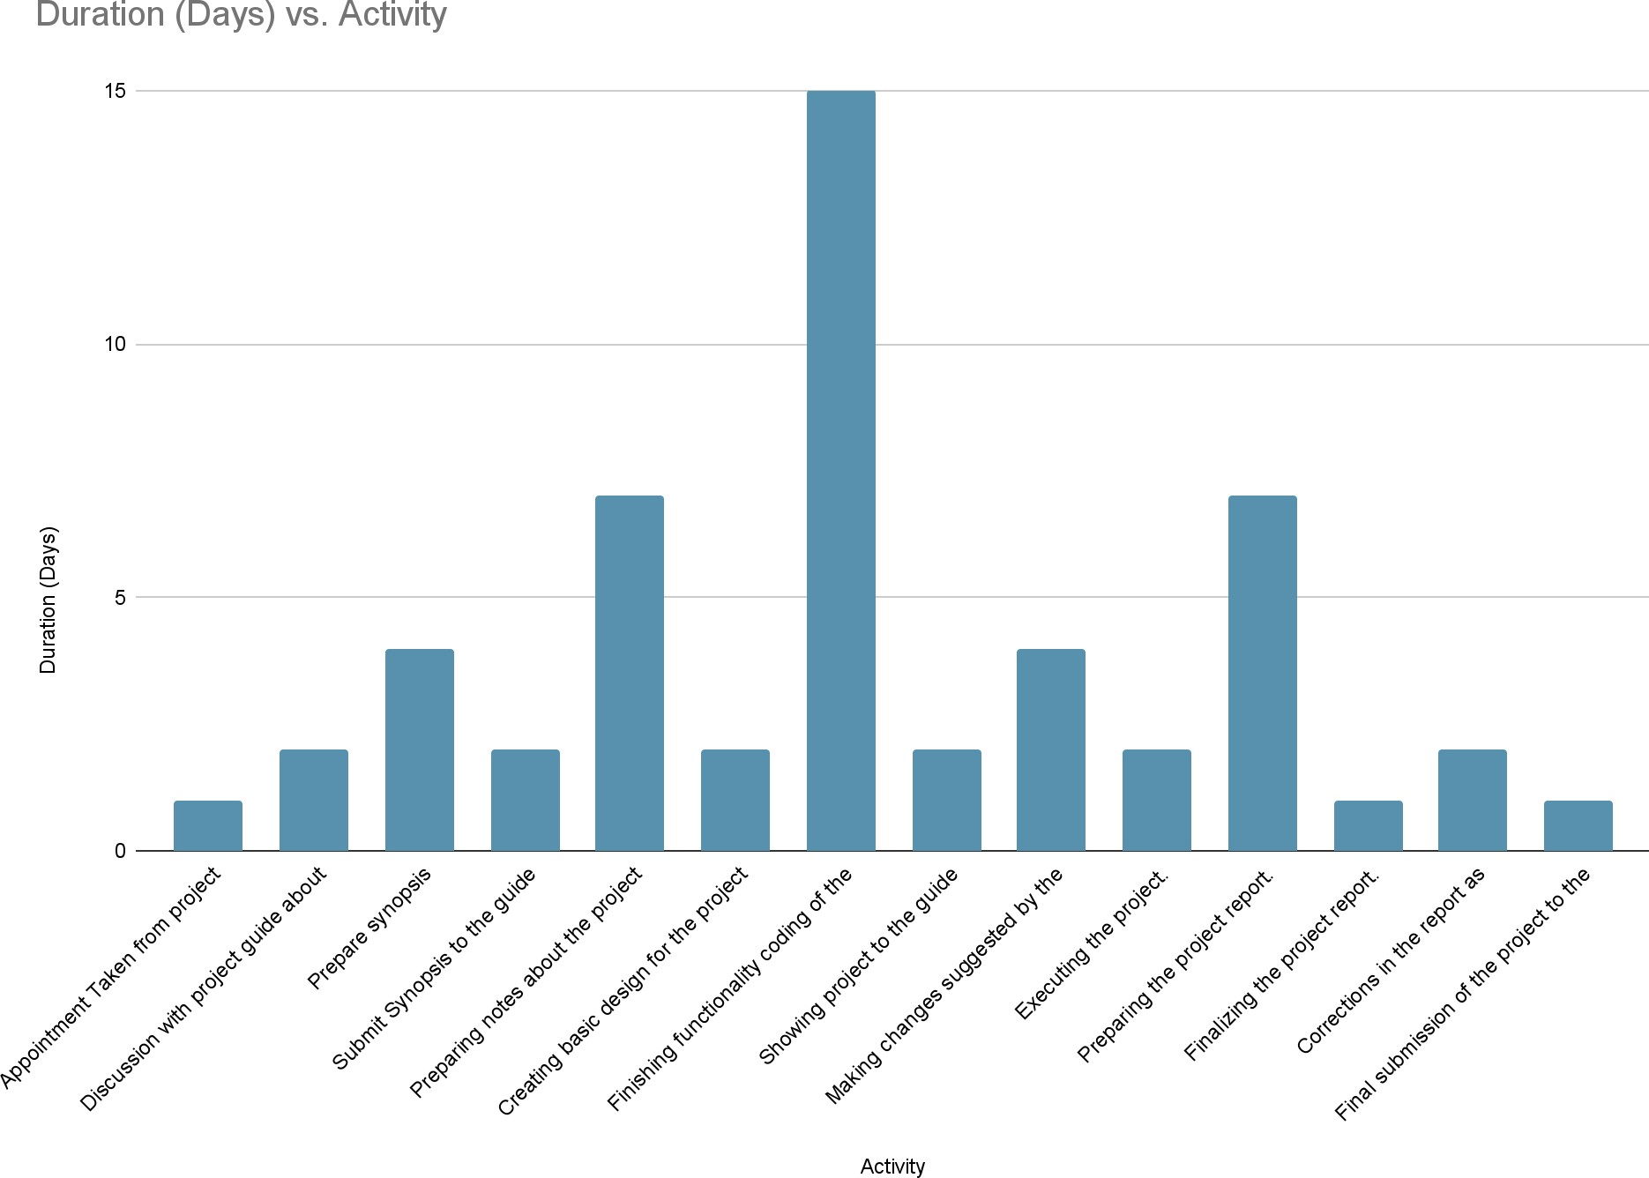

- MODULE DESCRIPTION

- User Module:

- This module manages user registration, user profile management, ride searching, ride booking, ride cancellation, ride history, review and rating, payment management, notification and messaging, security and privacy, and other features related to the system's users.

- User registration: A user can create a new account by providing their basic information such as name, email address, phone number, and a password.

- User profile management: Once registered, users should be able to update their profile information such as name, phone number, email address, profile picture, and other details.

- Ride searching: Users should be able to search for available rides based on the start and end location, time of the ride, and number of seats available. Ride booking: Users should be able to book a ride by selecting the ride from the search results and providing the required details such as the pickup location and the number of seats required.

- Ride cancellation: Users should be able to cancel their booked ride if they are unable to attend it.

- Review and rating: Users should be able to rate and review their co-passengers and drivers after the ride. This will help other users to make informed decisions while booking rides.

- Notification and messaging: Users should be able to receive notifications about their ride bookings, cancellations, and other important updates. They should also be able to send and receive messages to their co-passengers and drivers.

- Route planning: Passengers should be able to search for available routes by specifying their starting point and destination. The system should provide them with a list of available routes based on their search criteria.

- Route details: Passengers should be able to view details about the available routes, including the start and end location, the distance of the route, and the estimated travel time.

- Ride confirmation: Once a ride is booked, the system should confirm the ride with the passenger and the driver. The confirmation should include details such as the pick-up time, location, and the driver's contact details.

- Security and privacy: Driver's personal information should be kept secure and the system should comply with data protection regulations.
- Driver Module:

- This module manages driver registration, verification, and approval, ride offers, ride acceptance, ride management, earnings management, and other features related to the system's drivers.

- Driver registration: A driver can create a new account by providing their basic information such as name, email address, phone number, and a password.

- Driver verification and approval: Once registered, the driver's identity, driving license and vehicle information should be verified and approved by the system administrator.

- Ride offers: Drivers should be able to offer rides by specifying the start and end location, time of the ride, number of available seats, and other details.

- Ride acceptance: Drivers should be able to accept ride requests from passengers based on the passenger's location, time of the ride, and other factors.

- Ride management: Drivers should be able to manage their rides, including the ability to cancel a ride if necessary.

- Review and rating: Drivers should be able to rate and review their passengers after the ride. This will help other drivers to make informed decisions while accepting ride requests.

- Notification and messaging: Drivers should be able to receive notifications about ride requests, cancellations, and other important updates. They should also be able to send and receive messages to their passengers.

- Vehicle registration: A driver can register their vehicle by providing the vehicle's make, model, year, license plate number, and other details.

- Ride confirmation: Once a ride is booked, the system should confirm the ride with the passenger and the driver. The confirmation should include details such as the pick-up time, location, and the driver's contact details.

- Security and privacy: Users' personal information should be kept secure and the system should comply with data protection regulations.

- Admin Module:

- The admin module in a carpooling system allows the system administrators to manage the system and its users.

- User management: The admin module allows the system administrators to manage user accounts. The administrators can create new accounts, update existing accounts, and delete accounts as needed.
- Ride management: The admin module allows the system administrators to manage ride requests and ride offers. The administrators can view ride requests and offers, approve or reject them, and make changes to them as needed.

- Driver management: The admin module allows the system administrators to manage drivers in the system. The administrators can add new drivers, update driver profiles, and remove drivers as needed.

- Payment management: The admin module allows the system administrators to manage payments made by users. The administrators can view payment history, approve refunds, and resolve payment disputes.

- Reporting and analytics: The admin module allows the system administrators to view and analyse system data. The administrators can view ride statistics, user demographics, and other system-related information.

- System configuration: The admin module allows the system administrators to configure the system settings. The administrators can set pricing, configure email notifications, and adjust other system settings as needed.

- DATA MODELS LIKE 0, 1 AND 2 LEVEL DFDs

- A DFD also known as “bubble chart” has the purpose of clarifying system requirements and identifying major transformations. It shows the flow of data through a system. It is a graphical tool because it presents a picture. The DFD may be partitioned into levels that represent increasing information flow and functional detail. These are the notations used in DFD:-

- DATA FLOW. Data flow is represented by an arrow.

Data flow

- PROCESS. A circle or bubble represents a process that transforms incoming data to outgoing data.

Process

- EXTERNAL ENTITY. A square defines the source or destination of system data. It represents any entity that supplies or receive information from the system but it is not a part of system.

External Entity

- DATA STORE. The data store represents a logical file. A logical file can represents a data store symbol which can represents either a data structure or a physical file on disk. The data store is used to collect data at rest or temporary repository of data. It is represented by open rectangle.

Data store

- OUTPUT. The output symbol is used when hard copy is produced and the user of the copies cannot be clearly specified or there are several users of the output.

OUTPUT

- DFD:- 0-level

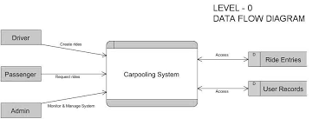

- DFD:- 1-level

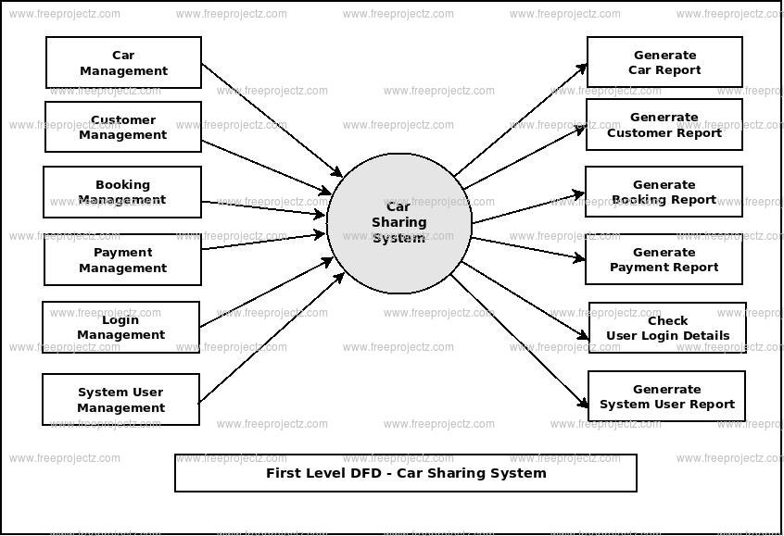

- DFD:- 2-level

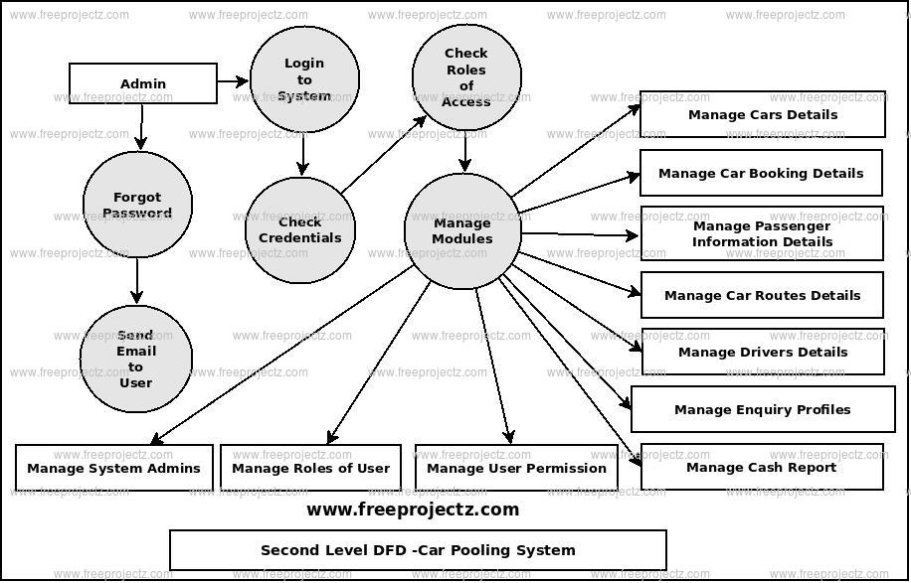

- ER DIAGRAM
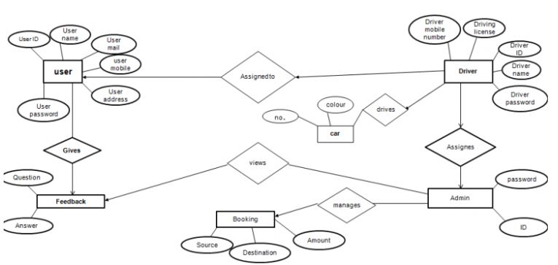

- CONCLUSION

- Carpooling is an important solution to tackle the rising issues of traffic congestion, environmental impact, fuel cost, and parking. In recent years, the popularity of carpooling has increased significantly due to advancements in technology and the increasing awareness of sustainable transportation. The development of carpooling systems has made it easy for users to find and share rides with others who have a similar destination.

- A successful carpooling system should provide a user-friendly interface that is easy to use, efficient in communication, and has a robust matching algorithm that ensures that users are matched with compatible ride partners. A well-designed system should prioritize user safety and security by implementing appropriate measures to protect user data and prevent unauthorized access.

- In addition, carpooling systems have the potential to bring social benefits by promoting shared mobility and building connections among users. By reducing the environmental impact of transportation, carpooling systems can contribute to a more sustainable future.

- To develop a successful carpooling system, hardware and software requirements should be taken into consideration. The system should have the capacity to handle increasing numbers of users and rides as the system grows. Scalability is an important factor to consider as the system should have the ability to grow and adapt as the user base expands.

- Customization is another important aspect of a successful carpooling system. The system should provide users with the ability to customize their preferences and settings. This includes the ability to set up ride alerts, preferred pick-up and drop-off locations, and other personalized features.

- Cost is also an important factor when considering the development of a carpooling system. The cost of developing and maintaining the system should be taken into account when deciding on the pricing model. The system should be affordable and accessible to users while ensuring that it is sustainable in the long run.

- In conclusion, carpooling systems have the potential to revolutionize transportation and contribute to a more sustainable future. By promoting shared mobility, reducing traffic congestion, and lowering carbon emissions, carpooling systems can bring numerous benefits to society, the environment, and the economy. A successful carpooling system should prioritize user safety and security, provide a user-friendly interface, have a robust matching algorithm, and be scalable and customizable. With careful consideration of hardware and software requirements, scalability, customization, and cost, a carpooling system can be developed that will benefit users, society, and the environment.

- BIBLIOGRAPHY

- https://www.w3schools.com

- https://www.w3docs.com

- https://www.tutorialspoint.com

- https://getbootstrap.com

- https://chat.openai.com/chat

- https://www.geeksforgeeks.org/

